EXERCISE 8 - JEAN RAVEN MAGALING

- How many unique salary packages does our company offer?
SELECT COUNT(DISTINCT salary) AS unique_salary_packages
FROM employee_data;
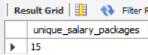
SELECT DISTINCT salary
FROM employee_data
ORDER BY salary DESC;
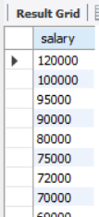
- How many distinct first names do we have in our database?
SELECT COUNT(DISTINCT f_name) AS unique_first_names
FROM employee_data;
